GNAT Developer’s Guide

Revision 0.25

Written and Developed by:

Bob Buehler, Matt Dissinger
Ray Myers, Kyle Owen

Index

Introduction 1

Cross-Platform Compatibility 1

Architecture 1

Top Structure 1

Base View Structure 2

Graph View Structure 3

Trace View Structure 4

Tracer Structure 5

Current “Quirks” 6

Future Work 6

Updating Doxygen 7

Updating the Installer
9

Introduction

GNAT is a Graphical AI Tracer designed to be used for facilitating in teaching and learning Artificial Intelligence. The first major portion of the program is the graph view. The graph view allows users to quickly and easily create graphs of both single agent graphs and adversarial trees on which various trace algorithms may be run. The second major portion of the program is the trace view. This view allows users to select any one of the built in algorithms and view a trace of the current graph using the selected algorithm.

Cross-Platform Compatibility

GNAT was designed with the QT4 graphical library, and as such, was built to be compatible with all operating systems for which QT is designed. This way, users are not restricted to only a Windows environment, but instead may utilize this tool on both Linux/UNIX and Macintosh operating systems as well.

Architecture, Top Structure

At the top is the CGNATWindow which is the top most class of the application, derived from the QMainWindow class in Qt. Every time the user selects to create a new file or open an existing file, a new IGNATView derived class is created based on the type of file.

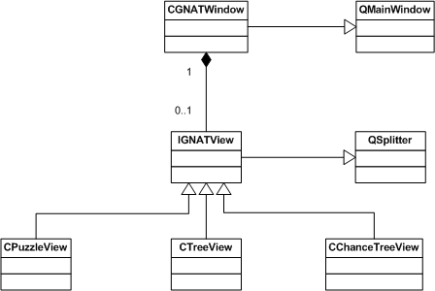

1
Architecture, Base View Structure

While the CGNATWindow can never contain a simple base IGNATView object, it will contain one of the 3 derived objects when a file is open for editing. These objects are all derived from the Qt class QSplitter in order to allow for the dual-pane view, as noted below.

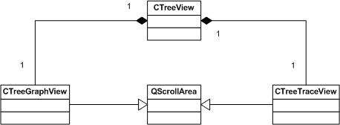

Each view (of the CPuzzleView, CTreeView, and CChanceTreeView) contains 2 child views, both derived from the Qt class QScrollArea. So far, all this gets us is the main window split into 2 separate areas. Majority of the work is done within the graph and trace views and their child objects. Each of the main views (puzzle, tree, and chance tree) will vary slightly in their editors and artists, but the general structure is still the same.

2
Architecture, Graph View Structure

The graph view contains modules of all the components (editors, artists, and the model). All the actual data for the graph itself is stored in the CTreeGraph class (or equivalent for puzzle and chance tree), but all data modification is required to be done through the model class. This allows for a simple data structure and associated save / load functions to be the only contents of the physical graph class, and more complex algorithms to be kept away from the data in the model class. This also allows for the safety of ensuring that only 1 class can modify the data, so it should always be aware of changes to the data and not create any unwanted side effects. Each of the modules is made aware of the model class and the canvas object when appropriate. Artist modules are responsible for painting the graph to the canvas, while editors allow for the actual objects to be edited (through context sensitive menus, etc).

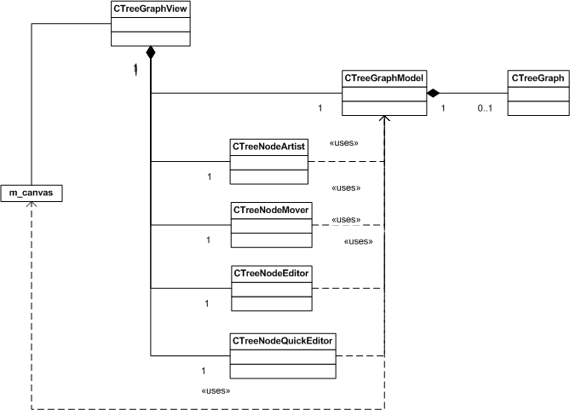

3
Architecture, Trace View Structure

The trace view is a subclass of the QTableWidget. The QTableWidget is a widget designed to show grids, and each cell can be any type of widget. In this implementation each cell is simply the QString of what would be written during a trace. The classes are linked as shown in this diagram.

CPuzzleTraceView
CPuzzleGraphModel
AI Config Menu
Depth Selectors
CPuzzleTracerSelector
ISingleAgentTracer
SPuzzleTrace
CUDTracer
CBDTracer

CTreeTraceView
CTreeGraphModel
AI Config Menu
Depth Selectors
CTreeTracerSelector
CGeneralMTracer
STreeTrace

4
Architecture, Tracer Structure

Adversarial

Formerly a plethora of classes all inheriting from an ITreeTracer interface class, the MiniMax tracing mechanism is now contained within the CGeneralMTracer class. The CTreeTracerSelector object passes a series of flags to CGeneralMTracer's trace member functions. These flags dictate what sort of search is to be done: alpha beta pruning, depth-limited, etc...

Single Agent

All single agent tracer classes inherit from the ISingleAgentTracer interface class. At the moment this contains two classes encompassing the two broad categories of search: CUDTracer (unidirectional) and CBDTracer (bidirectional). In addition to this distinction, the varieties of searches required several dimensions of polymorphism which will be discussed separately.

There are 5 different types of search, the sole difference between them being the way the open list is handled. These are Depth First, Breadth First, Uniform Cost, Greedy Best First, and A-Star. In a Depth First search, new nodes are add to the beginning of the open list. In a Breadth First search, they are added to the end. In a Uniform Cost search, the open list is sorted in order of path-cost. Greedy Best First search sorts in order of heuristic value. A-Star sorts in order of path-cost + heuristic value.

Since the only thing distinguishing these searches is the behavior of the open list, the tracer classes are templates of the open list type. The open lists themselves all inherit from the IOpenList interface class. Of them, the informed searches (Uniform Cost, Greedy Best First, and A-Star) inherit through the IInformedSearchOpenList interface class.

The remaining parameters (depth limit, iterative deepening, tree search vs. graph search) are passed to the trace member function of the tracer class. The parameters relating to depth limit simply influence the looping behavior of the function, while the third turns the closed list on or off. A graph search utilizes the closed list. A tree search does not.

5
Current “Quirks”

As the program stands, there are several quirks about the program which are known issues and need to be resolved.

When unhooking a node in the tree graph or calling auto-layout, the canvas is not properly resized to take into account the new graph size.

The words “Tree” and “Graph” still appear in the names of classes, etc... where “SingleAgent” and “Adversarial” would be more appropriate. Consider a mass renaming in the future.

Future Work

Below is a list of future work that contains items which were conceived during creation of the program but which time did not allow for.

High Priority

Chance tree view for expectant minimax algorithms.

Random tree/graph generation, just specify relevant information (bounds on values, number of nodes, depth, branching factor, etc).

Low Priority

Implement validations for the line edits in the puzzle and tree editors.
Use a more efficient sorting algorithm in the tree graph model’s sortChildNodes() function.

Add an option to automatically re-layout the tree when adding or deleting nodes.
Make repainting of the canvas more efficient by only repainting the areas which are modified.

Get the GNAT icon working in the program. Additionally, have the GNAT icon work for Windows explorer and the equivalents for Mac and Linux.

Qt does not currently have a method for determining the user’s default browser that is cross-platform compatible. As such, the original idea of having a help menu item which opened the help HTML page is not implemented and instead the Windows Installer places a link to the help page in the start menu if the user selects to add shortcuts. A more permanent solution is to find (or build) a library which will determine the user’s browser and display the help file in that browser, linked to a QAction in the help menu.
6
Updating Doxygen

Once files have been edited the Doxygen website for GNAT needs to be updated. In order to do this, first install the Doxygen file located under the Utilities directory of the SVN repository. Launch the program and load the file located in your sandbox under Documents\Doxygen\GNATDoxygen.cfg. Now click the “Expert” button as you will have to modify a few things for your sandbox. In each case, you are just modifying the path to match your directory structure. On the “Project” tab, change the following red circled items:

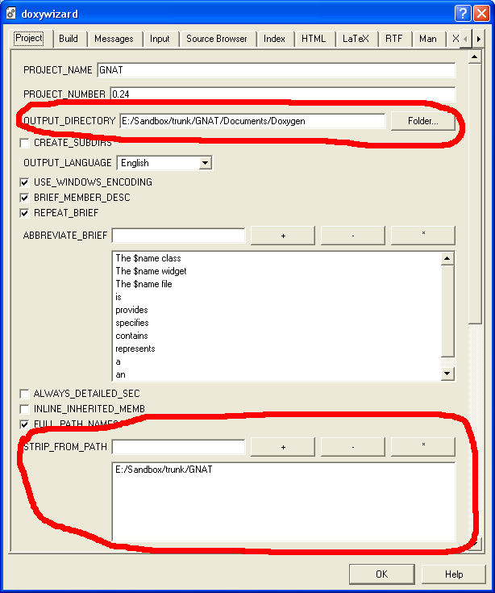

7
On the “Input” tab, change the following red circled items:

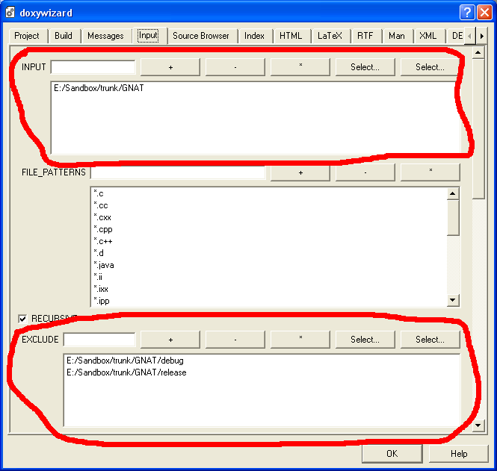

8
Updating the Installer

Any time the program is modified, it will need to be rebuilt and have a new installer created (which is located in the release directory, named SetupGNAT.exe). You will need to install the Nullsoft Installer (again, located under the Utilities directory, named nsis-2.11.exe). As long as you haven’t added new images to the help file, or additional pages to the help file, or required new DLLs, you will not need to edit the Nullsoft Installer script (GNAT.nsi).

Assuming you haven’t added files, you just need to repack the latest version. First, make sure to compile GNAT in release mode, so the latest release executable is located in the release folder. Then, compile the GNAT.nsi script file with the Nullsoft Installer (should be a context menu item for the file, if you right click on it). Once it is done compiling the script, you will have an updated SetupGNAT.exe which contains the latest executable and may be distributed or used to your discretion

9

